Chemistry quiz program

**Report:**

Client needs – program that helps Students recall scientific facts (chemistry)

Features-

* Test student with questions relating to the scientific theory studied in school, providing feedbacks (in form of scores) of student’s knowledge of the area.
* -Help student to be familiar with chemical elements alongside with the groups that the element belongs to. This includes displaying list of elements in a particular group, helping students find element’s group and testing student with questions relating to groups of elements
* Guiding student’s performance by showing their progress (in form of points) in each topic of chemistry.

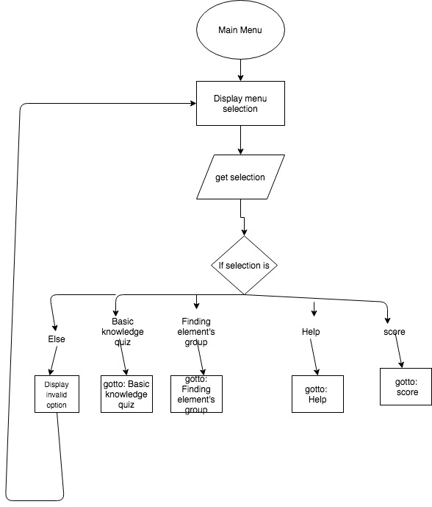

**Flowcharts:**

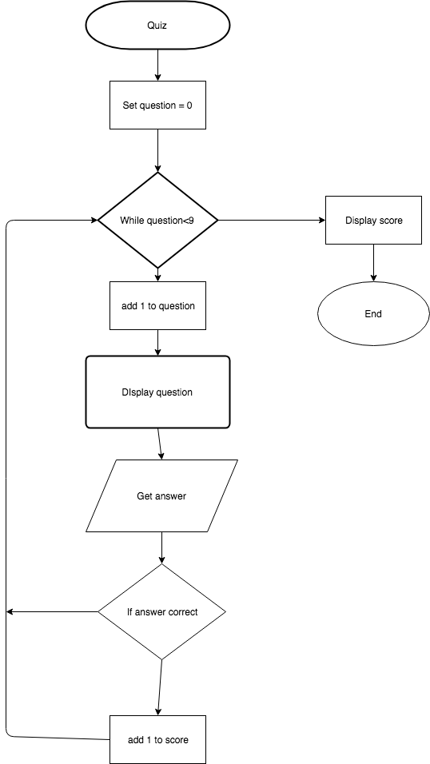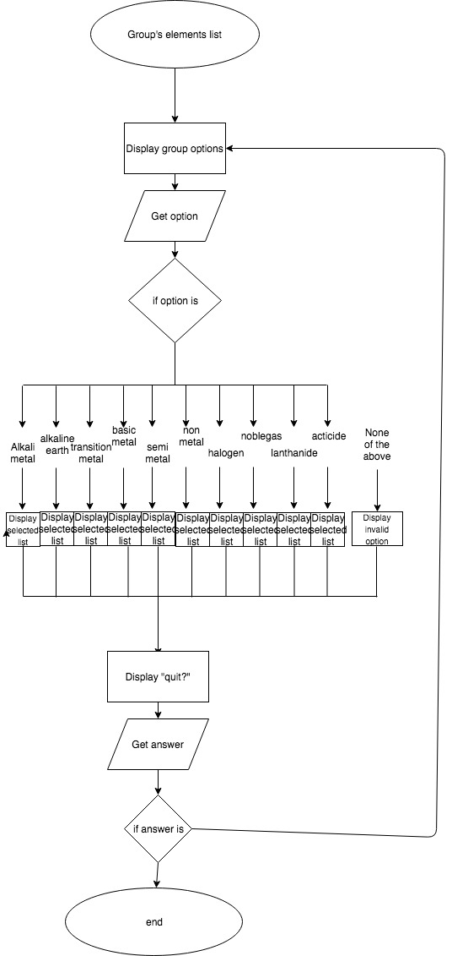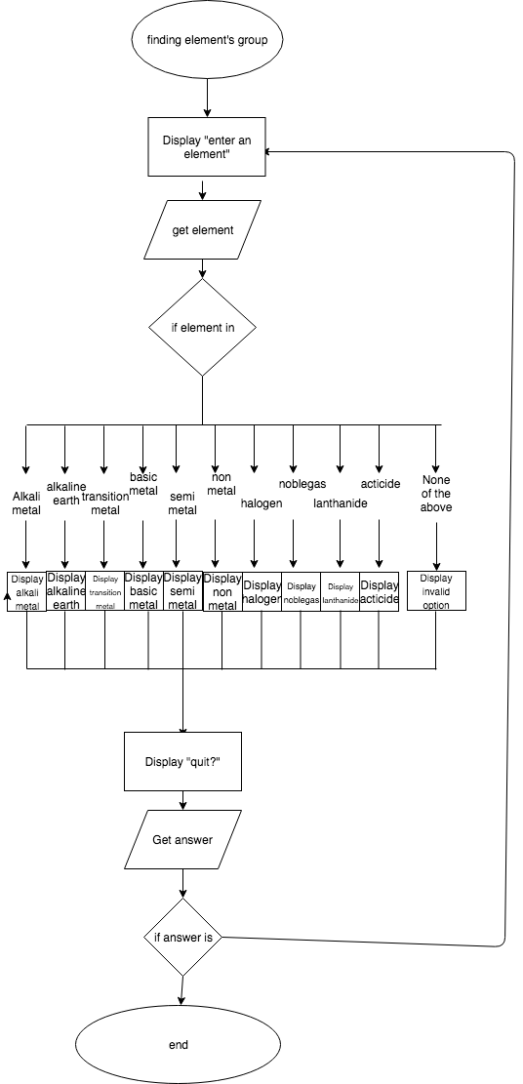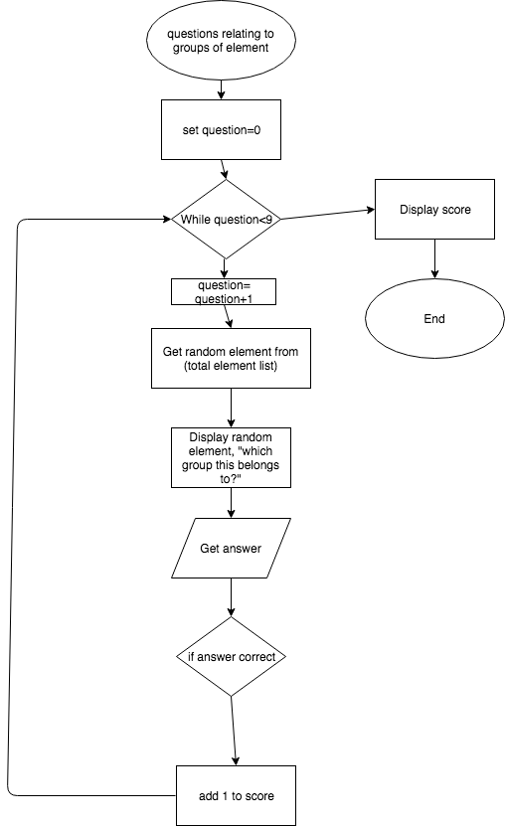

**Licensing**:

Freeware:

The program will be a freeware program this means that any people in the school or even outside the school can download the program for free but they cannot copyright it. Similar to twitter, Google and Facebook, the school can download the program in any-computer at any time for free. If someone wanted to improve the program by modifying it, they must ask permission or request to our company, as it is illegal to try copy and alter the program’s source code. Overall, this license helps the company to retain ownership of the program and sharing the program for free at the same time.

**Social and ethical issues related to project work**

**(Social) Inclusivity**

Social issues in software development are the problems the software may deliver, which are against the norms and values of society.

**-Cultural background**

The chemistry program 1.0 GUI consist only English language and therefore people with different background may need to learn the English language to interact with the GUI. This causes language barrier for people who wants to use the program but does not understand English.

**-Disability**

The chemistry program 2.0 does not provide additional user-program interface for disabled people particularly who is not able to see. The program is based on graphical interface, which means that it vastly relies on sense of sight. This segregates the people who is not able to see and hear from the people who is able.

**(Ethical)**

Ethical issues in software development are the problems relating to morals and principal that a program may deliver.

-This Program may promote laziness, by making it easy for student to find which group does an element belongs to without memorizing it.

-This Program may promote competitiveness around the students. Scores are given in every quiz in the program, which can cause students to be pressured to do good in the quiz and have low self-esteem when they get a bad mark.

**The elements of the system you have designed in terms of:**

Hardware-

The computer will be the hardware of my system.

Software-

The software would be the operating system of the computer and the idle of python, in order to run the program

Data-

The inputs of the user will be the data that is stored by my system. The name and the score of the users of the game will be store in separate text file.

Personnel-

The user of the system and the developer of the system.

Procedure-

To use the system you need to turn on computer, open the program through idle (python), select the courses you want to take in the menu, select quiz, enter your username and get your score.

**Fetch Executable Cycle**

Fetch Executable Cycle is the process in which the computer works to perform task, by obtaining, decoding, and executing data. This process will go in an ongoing cycle since the computer is turned on until the computer is shut down. This process is divided into 3 sub-process which are fetch, decode, execute and store.

The computer will first undergo the fetch cycle. In this cycle, the Program Counter(PC) in the CPU will generate an address, in which a particular instruction is stored in the main memory. The Memory Data Register (MDR) then need to go to the given address in the main memory in order to fetch the instruction back to the CPU, storing it in Memory Address Register (MAR).

Then it will go to the Decode cycle, in which the control unit, in the CPU, interprets the instruction stored in the MAR. The control unit decodes arithmetic/logic command in instruction and then tells the output devices how to respond to it.

After decoding the instruction, the computer will undergo the execute cycle, in which the instruction is executed. Arithmetic/Logic unit is use in the system to deals with instructions involving number and logistic. For example; to add 1 to 1 for arithmetic and to compare 2 is smaller than 5 for logic.

If the instruction requires the computer to store data, the computer will go to the store cycle. In here, results from the CPU are stored back to the main memory. This cycle is optional and not always needed.

**Assembly language vs machine language**

Programming languages are simply tools for human to create a set of instruction for the computer to perform a specific task. Overtime, new programming languages are created and developed, this results in a vast variety of programming languages, each having different advantages and disadvantages. These programming languages can be grouped in different generations, which are machine, assembly, high level and declarative language. Machine and Assembly language is two early generations of programming languages, having 2 different features

Machine language is the first programming language generation. The language’s set of instruction is the native language of computer’s processor, which can be easily decoded. This means that the language can run tasks faster than any other programming language. Unfortunately, the language can be difficult to decipher for humans as it only contains binary codes (1 and 0s). This means that to simply instruct computer to do simple task, programmer need to type a large series of 1 and 0s and one mistyped 1 or 0s can ruined to whole program. Overall, Machine language is a fast-efficient language but it is cumbersome at the same time.

On the other hand, Assembly language came after machine language making it the second programming language generation. The assembly is developed to make programming language easier for humans. Mnemonics are used to simplify the long series of 1 and 0s instruction into one command. Although it is perplexing compared to high-level language, mnemonics is less complicated than machine language as one mnemonic command is easier to remember than a long series of 1 and 0s command. Unfortunately, assembly language cannot be understand by computer’s processor, which means it have to be translated into machine language by a tool called an assembler. This makes it less efficient and time saving than machine language, as it requires time to convert assembly language to machine language but not as much as high-level language. In conclusion, Assembly language is less complicated but runs slower compared to machine language.

**History Events of GUI development**

In 1970s, Xerox developed the first computer that contains GUI, called “Alto”. Alto provides bit-mapped display, drop-down menus and icons which are the basic features of the GUI component. Then in 1981, Xerox produced another GUI computer called “Star”, its purpose is for businesses uses.

When Xerox developed the first GUI computer, Steve Jobs and Wozinack produced Apple I and then Apple II, which became the most popular personal computer during that time. This give their company, Apple a high reputation. Apple then employed Jeff Raskin, a former Xerox employee, in the following year. This led Steve Job to visit Xerox, as he was encouraged by Jeff Raskin, and improved and modify Xerox’s concept of GUI. As a result, Apple released “Lisa” in 1984.

During the development of Lisa, Apple created an agreement with Microsoft that Microsoft will create application for the Macintosh. When Microsoft was given the early version of Macintosh for further development, the founder of Microsoft Bill Gate was amazed on the potential the GUI had. This led to the development of the first Microsoft GUI operating system, “windows”, in 1985. There had been legal battle between Microsoft and Apple, in the development of GUI operating system, since then. The conflict was resolved when Apple gave windows a license, which allowed window to use the GUI features.

Eventually the CLI, command line interface, software was largely replace by GUI. Microsoft and Apple play a major role in this event by dominating the market, releasing versions of the GUI operating system. Until now, Microsoft and Apple are the biggest technological company and produced the most popular operating System.

Not only has GUI influence the features of Operating System, it has also influence in almost all technological system, in regards to the interaction between the user and the system. GUI has made the interaction between computer and human more intuitive, which inspires the software and program developed today to have GUI features.

Bibliography:

BusinessDictionary.com. (2018). *What comes after those ellipses?*. [online] Available at: http://www.businessdictionary.com/definition/ethical-issue.html [Accessed 1 May 2018].

Definitions.net. (2018). *What does social issues mean?*. [online] Available at: https://www.definitions.net/definition/social%20issues [Accessed 1 May 2018].

Bates, A. (2018). *SDD class module*. [online] Classroom.google.com. Available at: https://classroom.google.com/c/MTE1MTEwNDI2ODla [Accessed 1 May 2018].